西安瑞禧生物科技有限公司

Certificate of Analysis

General properties:
Name： NH2-PEG2000-NH2
Molecular Weight: 2000Dalton
Cat.#: R-1037
Lot.#: 558841
Manufacture Date: 2015.10.30
Date of Analysis: 2015.10.30
Recommended Retest date: 2016.10.30
Stability: 12 months
Storage: 2-8°C in the dark

Structure

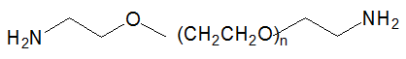

Items | Specification | Results
Appearance | White/off-white solid | White solid
¹H NMR | Identical to the Structure | Identical to the Structure
Foreign Material | None | None
Substitution | ＞90% | 90%
Report Date: 2015.10.30

This product is for research use only, Not for human or animal use

Xi'an ruixi Biological Technology Co., Ltd Web:http://www.xarxbio.com
Xi'an city ,Shaanxi Province, China http://www.resenbio.com
Tel: 0086 29 86354885 E-mail:sales@xarxbio.com

